Caitlan Nichols

23 August 2024

Module 3.2 - Assignment: GitHub Pages

HTML

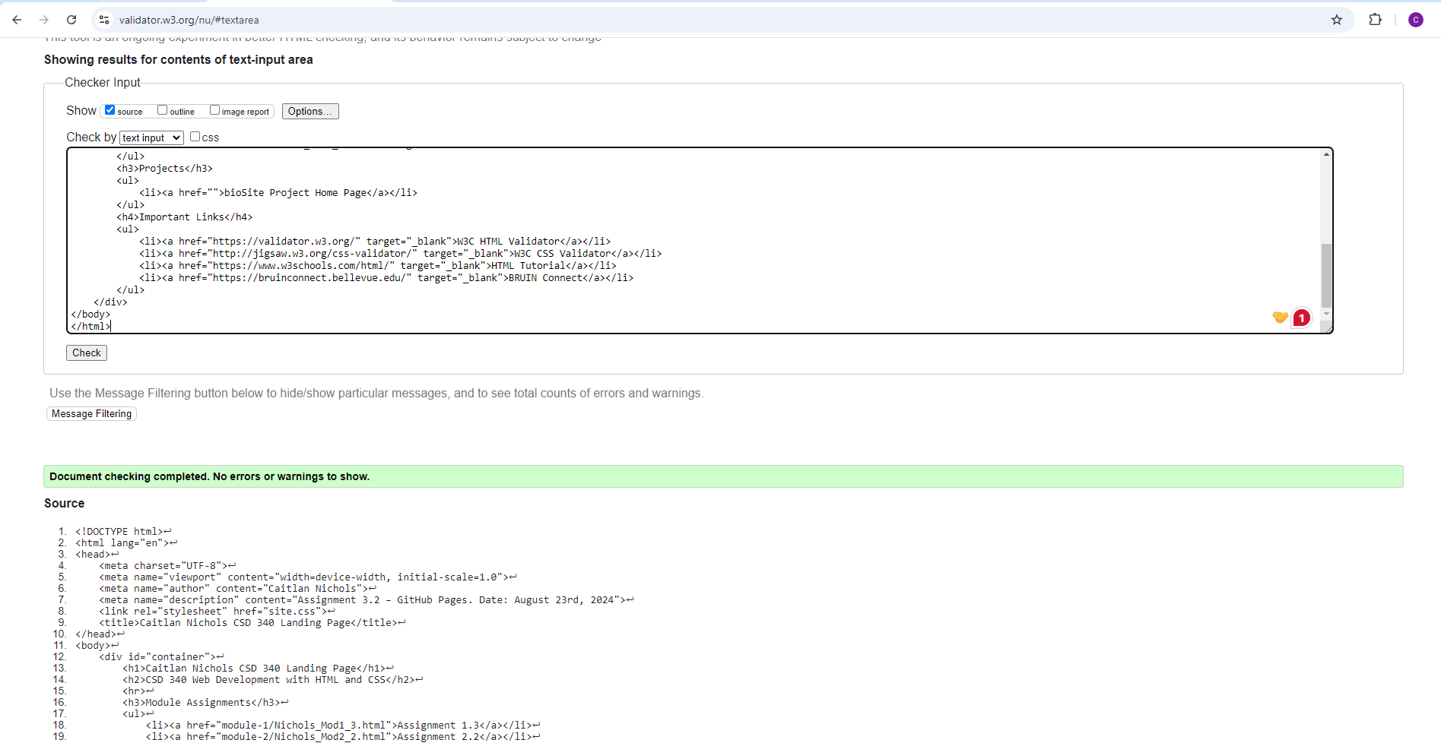

CSS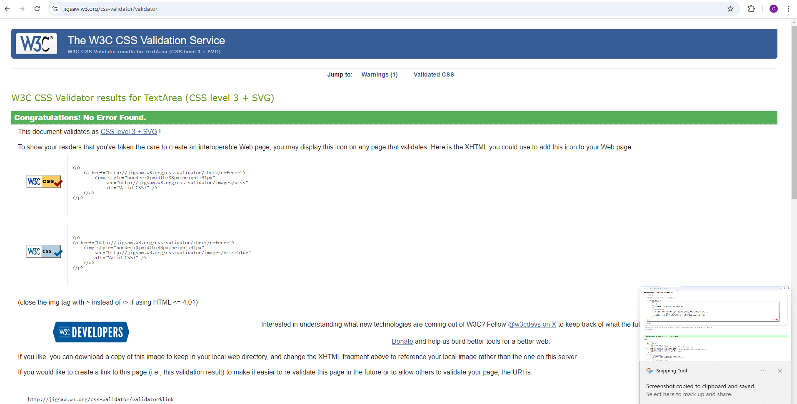

Website:  
